James River Runners

River Runners Technologies​

Erik Tiltman – Project Manager

Chris Calbi – Business Analyst

Ronny Georgi – Systems Analyst

Adam Noonan – Programming Coordinator

**MIS 4173 Information Systems Development & Implementation**

**Dr. Eric Kisling**

**Milestone 2**

Table of Contents

**Project Description** 3

Executive Summary 3

Current Environment 3

Proposed System Objectives and Constraints 3

Expected Benefits 3

Stakeholders 3

Context Diagram 3

**Use Case Package** 3

Executive Summary 3

Use Case Diagram 3

Use Case Specifications 3

Non-functional Requirements 3

# 

# **Project Description**

## Executive Summary

James River Runners a legal document carrier company located in Richmond, Virginia has grown exponentially since the beginning of the company back in 1999. As the company has grown more and more responsibility has been put on the owner, David Mccallum. With the growth of the company there has been a growing need for advancements in the process of how the business is run. After talking many times with the owner David, we were able to decide that there are two main issues that needed to be solved for the company to have continued competitive advantage in the market. The first was to set up an alert system that allowed the owner to receive messages based off when the customer needs a document delivered. the next problem we were able to solve was to set up an online form through a website we made, that allowed the costumer to fill out order forms online to take away the pressure of constant phone contact, which is currently how the company operates.

After completing this project, with the intentions of a successful system in place, we plan to take some of the weight of the owner and to make it more automated for the company. Moving to this system we want to put in place will not only help the efficiency of the company, but it will also help to allow customers to have more involvement through online ordering and will help Dave Mccallum to have better knowledge of when documents must be delivered. With these future implementations made by our team, James River Runners will be able to stay stable in the market, and even set up for more growth of the company in the future.

## Current Environment

When we look at the current environment of James River Runners, everything on the business process aspect of the company is completed manually and orders are made completely in accordance with the cellphone of David Mccallum. They currently have no information systems in place and all parts of the company including accounting, logistics, and ordering are subject to manual labor either done by the owner or completed by the members of Dave’s team.

Working with Dave Mccallum has given our team a wonderful chance to set up the first BPA system that will not only benefit for Dave but will benefit for the entire company to have their first system put in place. Because there are no current systems, our team was able to set a system of free of current system integration.

## Proposed System Objectives and Constraints

## 

Working with James River Runners to solve their business need, our team is creating a Business Process Automation System that will convert his manual, paper-based business processes and documentation in to an easy-to-use information system. While the company’s “runners” will still be transporting legal documents from one location to another, the entire system around them will be automated. Upon consulting with company owner Dave Mccallum about his goals for the project, we have determined the requirements and constraints as follows:

Functional Requirements:

* + Website with company background and information
  + Log-in portal for customers, runners, and owner
  + Customer must be able to enter order information
  + Customer receives order confirmation via email
  + Customer receives delivery confirmation & receipt via email
  + Runners must be able to enter expenses incurred

Non-functional Requirements:

* + Availability 24 hours per day, 365 days per year
  + Run on all commonly used web browsers such as Internet Explorer, Mozilla Firefox, Safari, Google Chrome, and Opera
  + Work on full scale and displayed properly on any common mobile web browser
  + Orders must be limited to central and eastern Virginia
  + Automated backups from customers and runners data
  + Displayed screen must refresh within 2s
  + Apache Server with MySQL

Constraints:

* + Analysis presentation (2/12)
  + Design presentation (3/14)
  + Structured walkthrough (3/26)
  + Training presentation (4/09)
  + Final presentation (4/30)

Expected Benefits

Overcoming our constraints is vital to project success and we are extremely confident that we will be able to overcome these while maintaining all functional and non-functional requirements. The expected benefits that will be delivered to James River Runners include paper-less billing and documentation for all parties (customer, runner, owner) as well as no time limitations for customers as they will now specify desired pick-up and delivery times. Our Business Process Automation will lead to electronic alerts for customers, immediate tracking of expenses incurred for Mr. Mccallum, and generated salary reports for runners.

## Stakeholders

The legal document carrier company James River Runners located in Central Virginia, has various stakeholder’s that will be affected by our new system and will have to transition with the ways of our system we are putting in place. The first being the Owner, David Mccallum. Then we have the costumers located in Richmond and its surrounding areas requesting a delivery, our project team that is working on this system and of course the runners who deliver the requested order at specific times throughout the year

## 

## Context Diagram

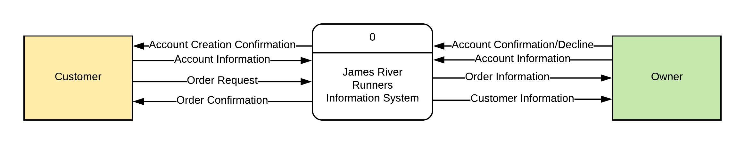

## **Use Case Package**

## Executive Summary

## Use Case Diagram

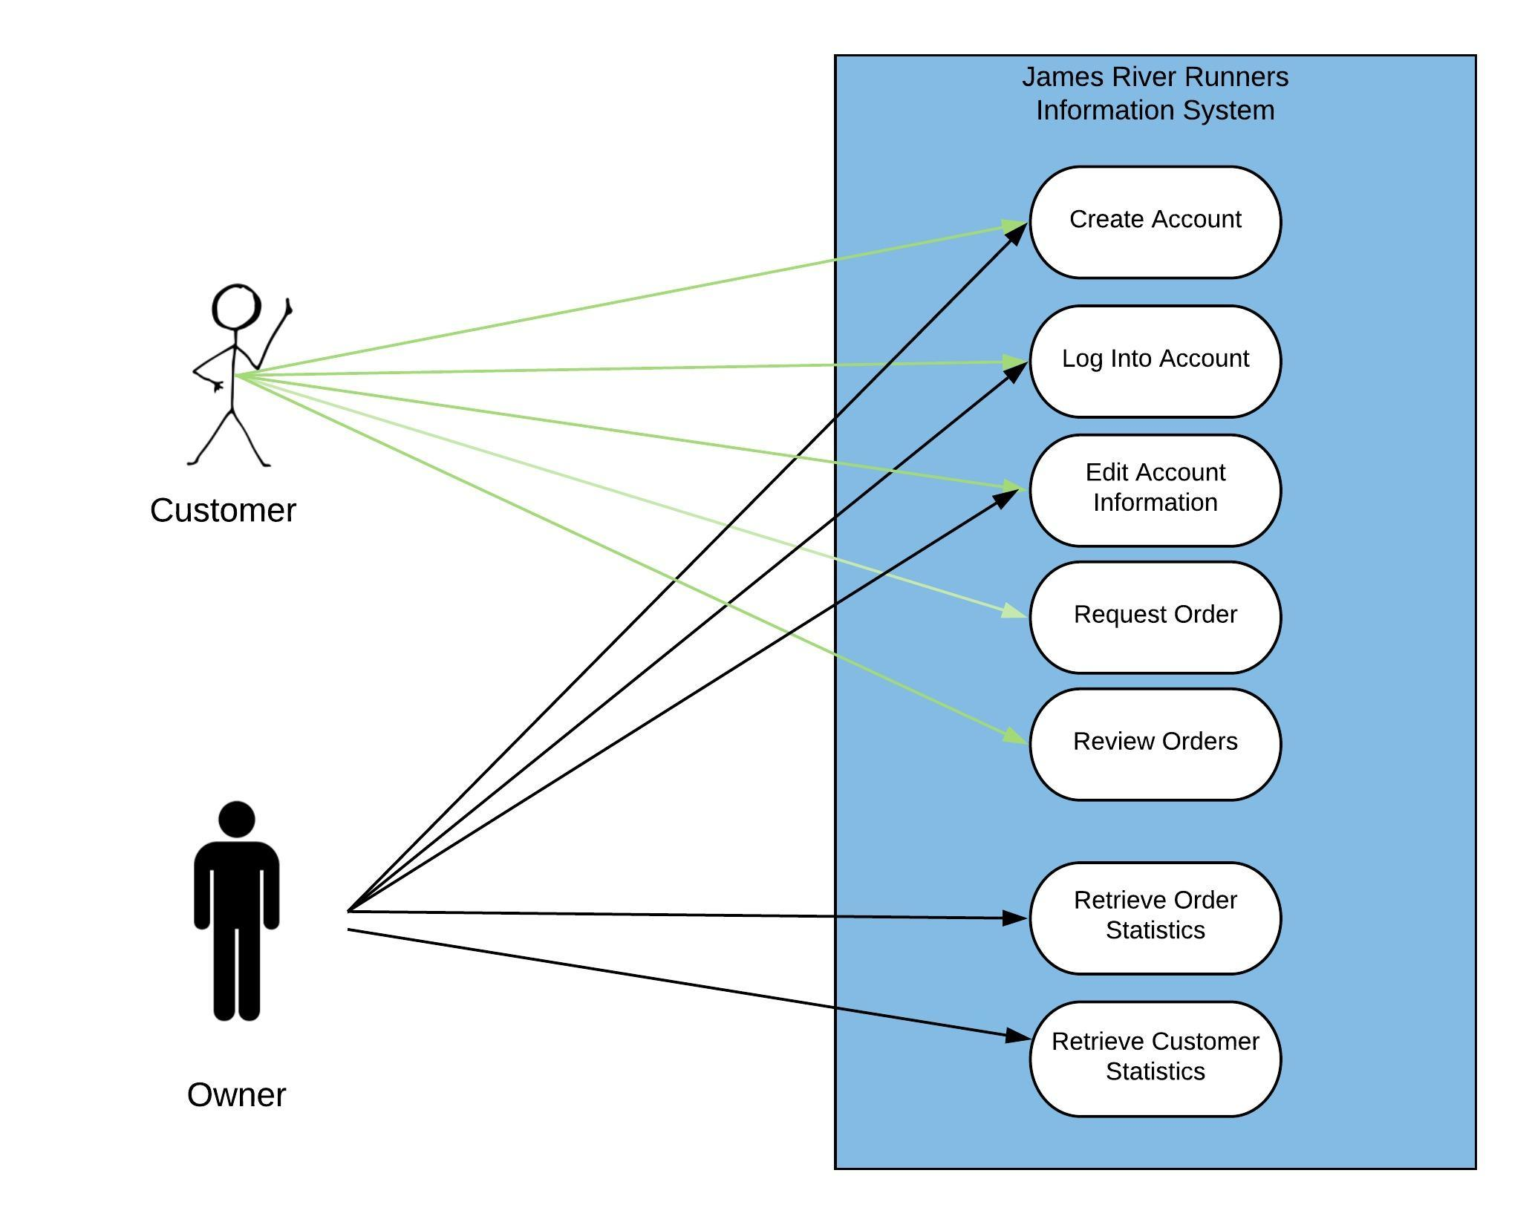

## Use Case Specification: Create Account

|  |  |  |  |  |  |  |
| --- | --- | --- | --- | --- | --- | --- |
| **Use Case Name:**  Create Account | | | | **ID:**  UC-1 | | **Priority:**  High |
| **Actor:** Customer/Owner | | | | | | |
| **Description:** Unregistered User goes through account registration process | | | | | | |
| **Trigger:** Customer selects “Sign Up” button from Drop-down menu **Type:**  External  Temporal | | | | | | |
| **Preconditions:**   1. User is not logged into an account. 2. User is at website’s homepage. | | | | | | |
| **Normal Course:**   * 1. Customer selects “Create Account” button from drop-down menu.   2. Customer enters required information.   3. System processes request & sends verification   request to owner.   * 1. Owner responds with Confirmation  1. Confirmed Customer account is generated;   relevant data fields stored   1. Confirmation email sent to customer | | | **Information for Steps:**  Client Information: LName, FName, Address, City, Zip, email, phone number  Account Request notification email  Confirmation of Account Request  Client Information: LName, FName, Address, City, Zip, email, phone number  Confirmation Email | | | |
| **Alternative Courses:**   * 1. User input is missing a required field.   2. User receives notice to complete required fields.   2.0 The user provides invalid input.  2.1 User receives notice of invalid input provided.  3.0 The account registration request is denied by owner.  3.1 Account request is deleted with no notice given to user. | | | **Information for Alt. Course Steps:**  Notice of required fields  Notice of invalid input  Decline of Account Request  Decline of Account Request | | | |
| **Postconditions:**   1. A customer now has an account saved in our system and can log in. 2. Our database has customer account saved and is ready to store order data. | | | | | | |
| **Exceptions:** | | | | | | |
| **Summary Inputs:**  Client Information: LName, FName, Address, City, Zip, email, phone number  Confirmation or Deletion of Account Request | **Source:**  Customer/Owner | **Outputs:**  Notice of required fields  Notice of invalid input  Account Request to Owner  Decline of Account Request  Confirmation email for Customer | | | **Destination:**  Owner, Customer Data Store | |

## Use Case Specification: Log Into Account

|  |  |  |  |  |  |  |
| --- | --- | --- | --- | --- | --- | --- |
| **Use Case Name:**  Log Into Account | | | | **ID:**  UC-2 | | **Priority:**  High |
| **Actor:** Customer/Owner | | | | | | |
| **Description:** Customer or Owner logs into respective account | | | | | | |
| **Trigger:** Log-in Attempt **Type:**  External  Temporal | | | | | | |
| **Preconditions:**   1. User is at website and not logged in. 2. User has a registered account username/email & password. | | | | | | |
| **Normal Course:**   * 1. Select “Log-In” from Drop-down Menu   2. User inputs account username & password.   3. System logs Customer into their account or Owner into Admin account. | | | **Information for Steps:**  Username & password  Log-in Confirmation | | | |
| **Alternative Courses:**   * 1. The username or password does not match a registered account.   2. User is asked to re-enter username & password or contact Owner for assistance.  1. The owner provides Admin username & password.   2.1 System logs Owner into Admin account. | | | **Information for Alt. Course Steps:**  Invalid username/password  Notification of Denial  Admin username & password  Log-in Confirmation | | | |
| **Postconditions:**   1. System now allows Customer to access request orders, view orders or edit account information. 2. System now allows Owner to retrieve order statistics or customer statistics. | | | | | | |
| **Exceptions:** | | | | | | |
| **Summary Inputs:**  Username & password  Invalid Username/password  Admin Username & password | **Source:**  Customer  Owner | **Outputs:**  Log-in Confirmation  Notification of Denial | | | **Destination:**  Webpage | |

Use Case Specification: Request an Order

|  |  |  |  |  |  |  |
| --- | --- | --- | --- | --- | --- | --- |
| **Use Case Name:**  Request Order | | | | **ID:**  UC-3 | | **Priority:**  High |
| **Actor:** Customer | | | | | | |
| **Description:** Logged in customer requests a document delivery. | | | | | | |
| **Trigger:** Customer requests a delivery through website. **Type:**  External  Temporal | | | | | | |
| **Preconditions:**   1. User is already logged into verified customer account. | | | | | | |
| **Normal Course:**   * 1. Customer selects “Place an order” from drop-down menu   2. Customer enters required fields & submits order  1. Order Request email is sent to Owner   2.1 Owner confirms order or denies order  2.2 Order Confirmation email is sent to Customer  3.0 Order Information stored in Customer Data Store | | | **Information for Steps:**  Order Information: Pickup & drop-off location, date & time, number of documents, package type, extra notes.  Order Request email  Confirmed Order processed  Order Confirmation email  Customer Data Store updated with latest order | | | |
| **Alternative Courses:**   * 1. Owner denies order   2.0 Customer enters invalid input for required field  2.1 Customer receives Invalid Input notice | | | **Information for Alt. Course Steps:**  Order is not processed  Invalid Input notice | | | |
| **Postconditions:**   1. Order Information is confirmed and stored in Customer Data Store. 2. Order Information is accessible both by Owner & Client. | | | | | | |
| **Exceptions:** | | | | | | |
| **Summary Inputs:**  Order Information | **Source:**  Customer | **Outputs:**  Confirmed Order, Updated Customer Data Store | | | **Destination:**  Customer Data Store | |

## Use Case Specification: Edit Account Information

|  |  |  |  |  |  |  |
| --- | --- | --- | --- | --- | --- | --- |
| **Use Case Name:**  Edit Account Information | | | | **ID:**  UC3 | | **Priority:**  Medium |
| **Actor:** Customer, Owner | | | | | | |
| **Description:** The customer and owner are logged into the system. They want to change some previously entered information of their account. The customer also wants to delete his account if he decides that he doesn’t want to work with the company any more or he wants to create a new account later. | | | | | | |
| **Trigger:** The customer wants to edit his/her account information. **Type:**  External  Temporal | | | | | | |
| **Preconditions:**   1. The customer and owner (C&O) are logged in and their IDs are identified by the system. | | | | | | |
| **Normal Course:**  1.0 The customer and owner enter my account section   1. The C&O select my account 2. The system displays the current account information of C&O   2.0 The C&O edit existing account information   1. The C&O edit the desired fields 2. The C&O select Submit 3. The system asks for confirmation of changes 4. The C&O confirm changes in their account data 5. The system displays confirmation message 6. The system displays the logged in homepage   3.0 The customer wants to delete her/his account   1. In the My Account section the customer selects   Delete Complete Account   1. The system asks for confirmation of deletion 2. The customer confirms deletion of the account 3. The system asks for password verification 4. The customer enters her/his password and   verifies deletion   1. The system displays confirmation message 2. The system displays the logged off homepage | | | **Information for Steps:**  My Account Page  Current Account Information (Name. E-mail, Password, Address)  Editing of Fields (Account Information)  Submit  Confirmation Request  Confirmation, New Account Information  Confirmation Message  Logged in Homepage  Delete Complete Account  Confirmation Request  Confirmation  Password Verification Request  Password  Confirmation Message  Logged Off Homepage | | | |
| **Alternative Courses:**  2.1 The C&O submit the new account information  without having filled out all required fields  required data fields   1. The system displays message that all required   fields need to be filled out   1. The system marks the required unfilled fields 2. The C&O fill out all required fields 3. The system displays confirmation message 4. The system displays the logged in homepage | | | **Information for Alt. Course Steps:**  Missed Account Data  Info Message  Marked Fields  Filled Required Fields  Confirmation Message  Logged in Homepage | | | |
| **Postconditions:**  1. All updates in the account information are transferred correctly in the data storage. | | | | | | |
| **Exceptions:** | | | | | | |
| **Summary Inputs:**  Updated Account Information | **Source:**  Customer | **Outputs:**  Updated Account Information | | | **Destination:**  Customer, Customer Data Store | |

## Use Case Specification: Review Orders

|  |  |  |  |  |  |  |
| --- | --- | --- | --- | --- | --- | --- |
| **Use Case Name:**  Review Orders | | | | **ID:**  UC5 | | **Priority:**  Medium |
| **Actor:** Customer | | | | | | |
| **Description:** The customer is logged into the system. The Customer wants to see the document orders that she/he did with the company in the past. | | | | | | |
| **Trigger:** The customer wants to see the past orders. **Type:**  External  Temporal | | | | | | |
| **Preconditions:**   1. The customer is logged in and her/his ID is identified by the system. | | | | | | |
| **Normal Course:**  1.0 The customer enters my orders section   1. The Customers selects my orders 2. The system displays a summarized overview of   all orders  2.0 The customer wants to see all details about a specific  past order   1. The Customer selects All Details next to the   order   1. The system displays all details to the specific   order  3.0 The customer wants to see all orders together again   1. The customer selects Back To All Orders 2. The system displays a summarized overview of   all orders | | | **Information for Steps:**  My Orders Page  All orders summarized  All Details  All Order Data (Doc. Type, Order & Delivery Date, Pick-Up & Delivery Location)  Confirmation  Back To All Orders  All orders summarized | | | |
| **Alternative Courses:**  1.1 The customer wants to see past orders, but hasn’t  made any orders under the current account yet  fields need to be filled out   1. The Customers selects my orders 2. The system displays a blank page with a text information that no orders have been made yet | | | **Information for Alt. Course Steps:**  My Orders Page  Blank page, text info | | | |
| **Postconditions:**  1. All past orders for the specific account have been stored correctly in the data storage. | | | | | | |
| **Exceptions:** | | | | | | |
| **Summary Inputs:**  My Orders request | **Source:**  Customer | **Outputs:**  Order overview & details | | | **Destination:**  Customer, Order Data Store | |

## Use Case Specification: Retrieve Customer Statistics

|  |  |  |  |  |  |  |
| --- | --- | --- | --- | --- | --- | --- |
| **Use Case Name:**  Retrieve Customer Statistics | | | | **ID:**  UC6 | | **Priority:**  Medium |
| **Actor:** Owner | | | | | | |
| **Description:** The owner is logged into the system. He wants to see various statistics about the structure of his customer base. | | | | | | |
| **Trigger:** The owner wants to see customer statistics. **Type:**  External  Temporal | | | | | | |
| **Preconditions:**     1. The system is up to date and online. 2. The owner is logged in and his ID is identified by the system. 3. Multiple customers have already been entered in the customer database. | | | | | | |
| **Normal Course:**  1.0 The owner enters the customer statistics section   1. The owner selects on Customer Statistics 2. The system displays a list with all customers and shows the total customer amount   2.0 The owner wants to see his top five customers   1. The owner selects Top 5 Customers 2. The system displays the top 5 customers and the amount of their orders   3.0 The owner wants to see a chart for location distribution  (location of customers)   1. The owner selects Location Distribution 2. The system displays a chart that shows   distribution of locations by counties  4.0 The owner wants to see the monthly development of  his customer bases   1. The owner selects Monthly Development 2. The system displays a chart for the monthly   customer development | | | **Information for Steps:**  Customer Statistics  Customer List  Top 5 Customers  Top 5 Customer Names & Order Amounts  Location Distribution  Location Distribution Chart  Monthly Development  Monthly Development Chart | | | |
| **Alternative Courses:** | | | **Information for Alt. Course Steps:** | | | |
| **Postconditions:**  1. The owner viewed his customer statistics successfully. | | | | | | |
| **Exceptions:** | | | | | | |
| **Summary Inputs:**  Customer Statistics request | **Source:**  Owner | **Outputs:**  Customer Statistics Numbers & Charts | | | **Destination:**  Owner, Customer Data Store, Order Data Store | |

## Use Case Specification: Retrieve Order Statistics

|  |  |  |  |  |  |  |
| --- | --- | --- | --- | --- | --- | --- |
| **Use Case Name:**  Retrieve Order Statistics | | | | **ID:**  UC7 | | **Priority:**  Medium |
| **Actor:** Owner | | | | | | |
| **Description:** The owner is logged into the system. He wants to see various statistics about the past orders in his business. | | | | | | |
| **Trigger:** The owner wants to see the order statistics. **Type:**  External  Temporal | | | | | | |
| **Preconditions:**     1. The system is up to date and online. 2. The owner is logged in and his ID is identified by the system. 3. Multiple orders have already been entered in the order database. | | | | | | |
| **Normal Course:**  1.0 The owner enters the order statistics section   1. The owner selects on Order Statistics 2. The system shows the total amount of orders   that were made this year.  2.0 The owner wants to see the monthly development of the  orders   1. The owner selects Monthly Development 2. The system displays a chart for the monthly development of order amounts   3.0 The owner wants to see the weekly development of the  orders   1. The owner selects Weekly Development 2. The system displays a chart for the weekly development of order amounts | | | **Information for Steps:**  Order Statistics  Total Order Amount  Monthly Development  Monthly Development Chart  Weekly Development  Weekly Development Chart | | | |
| **Alternative Courses:** | | | **Information for Alt. Course Steps:** | | | |
| **Postconditions:**  1. The owner viewed his order statistics successfully. | | | | | | |
| **Exceptions:** | | | | | | |
| **Summary Inputs:**  Order Statistics request | **Source:**  Owner | **Outputs:**  Order Statistics Numbers & Charts | | | **Destination:**  Owner, Order Data Store | |

## Non-functional Requirements